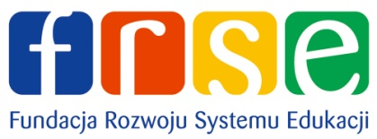 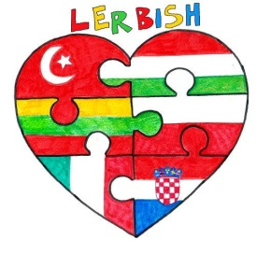 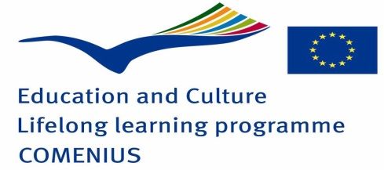
NAME.....................................................
QUESTIONNAIRE ABOUT POLAND
1-What is the capital city of Poland?

2-Circle the Polish flag below.
A 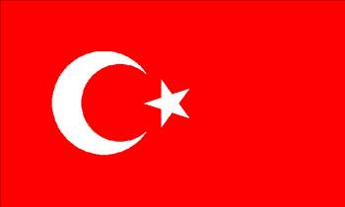 B 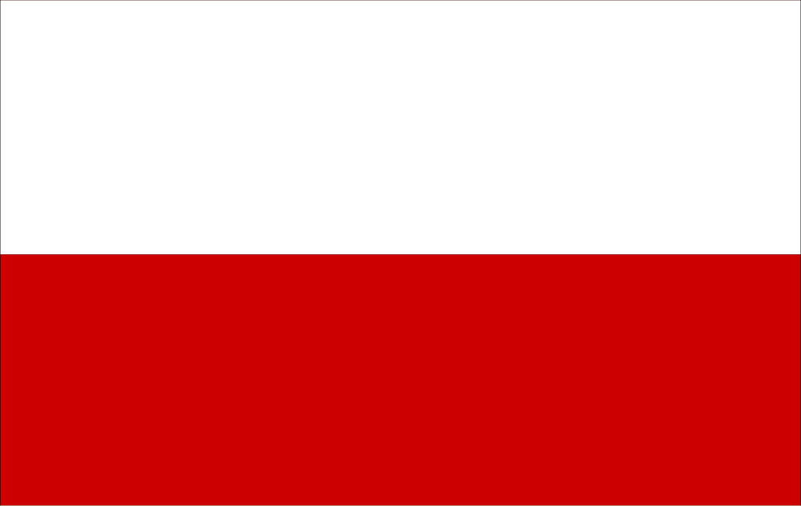 C 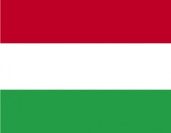

D 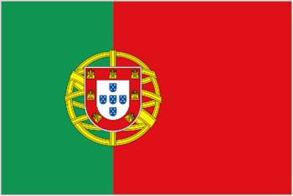 E 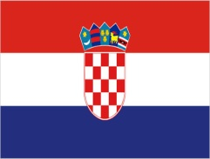 F 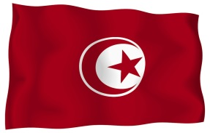

3-Which one is the traditional costume of Poland?
A 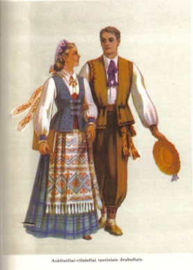 B 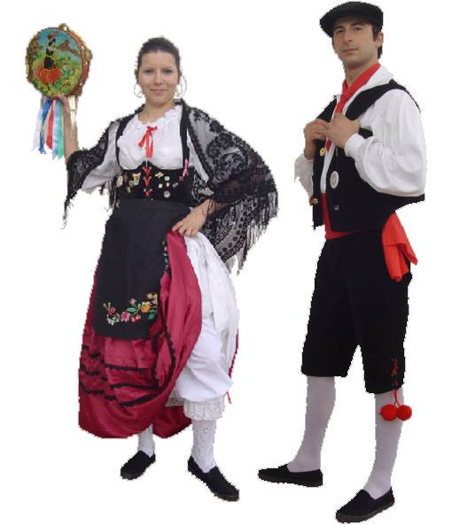 C 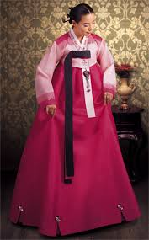
D 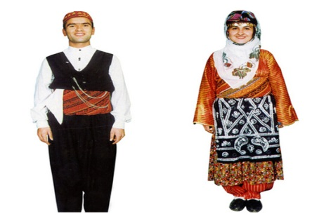 E 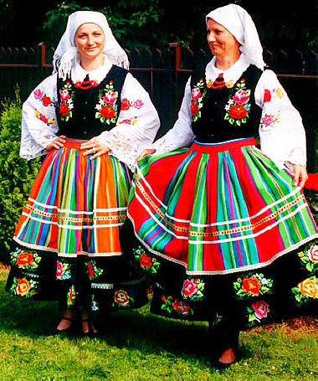

4-Which one is the Polish dish?
A 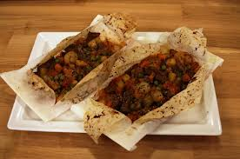 B C 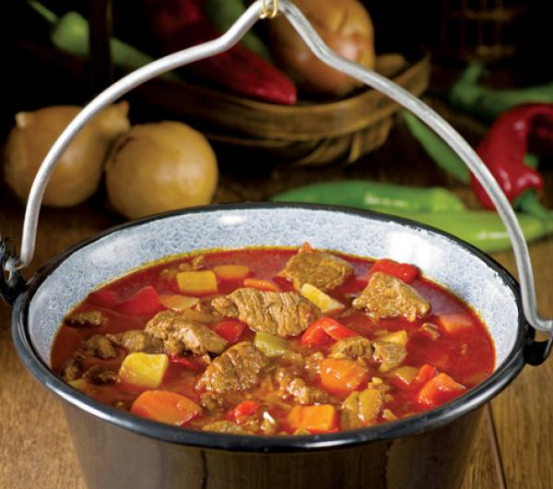
D 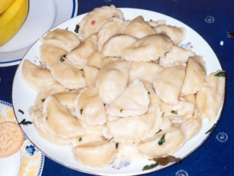 E 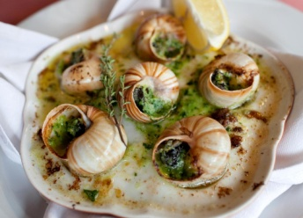 F

5-Please write 3 popular places in Poland.

6-In which village are you doing this Comenius Project with in Poland?

7-What is Poland famous for?

8-Which one is the name of Polish school?
a) Gimnazjum im. Henryka Sienkiewicza w Łodzi
b) Gimnazjum nr 5 w Piotrkowie Trybunalskim
c) Gimnazjum im. Marii Konopnickiej w Szydłowie
d) Primary Szhool in Szydłów

9-What does ‘’ Dzień dobry’’ mean in Polish?
A. good morning B. goodbye C. see you
D. Nice to meet you E. thank you

10-Match the numbers with their meanings.
- 1 1) pięć
- 2 2) cztery
- 3 3) jeden
- 4 4) trzy
- 5 5) dwa

GOOD LUCK!
Sylwia Bernacka

