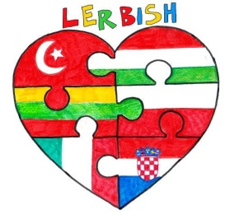
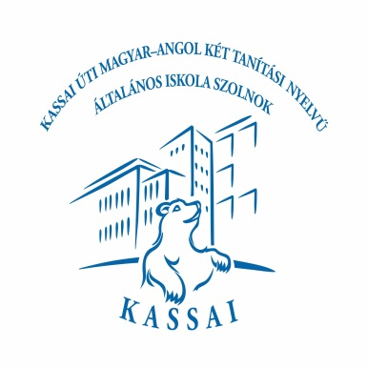

Questionnaire about Hungary
1-What is the capital city of Hungary?

2-Circle the Hungarian flag below.
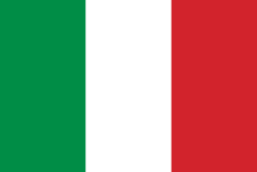
- b) 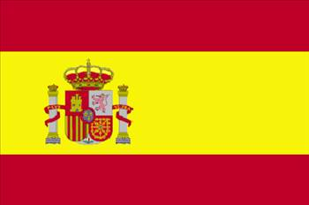 c) 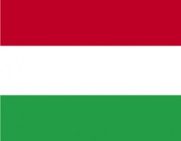

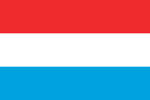
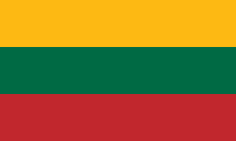
d) e) 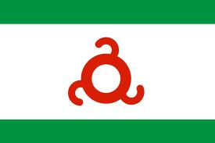 f)
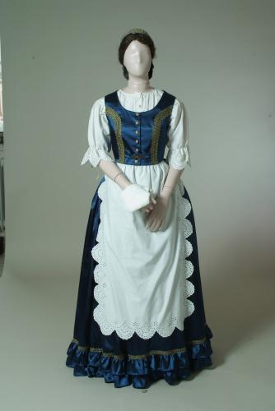
3-Which one is the traditional costume of Hungary?
- 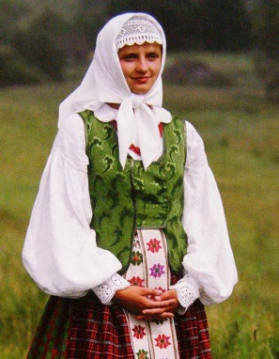 b) 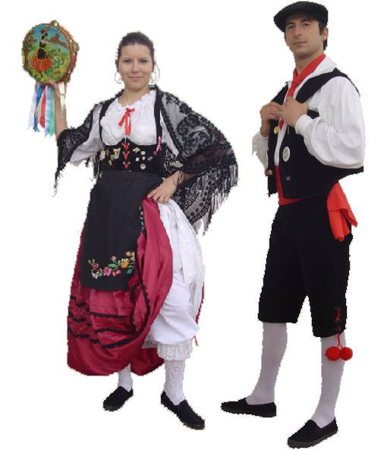 c )
d) 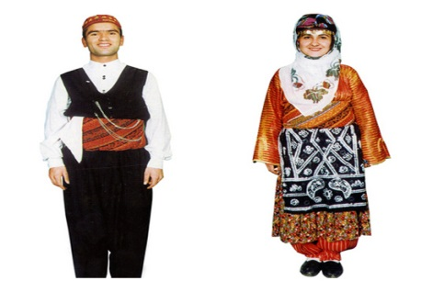 e) 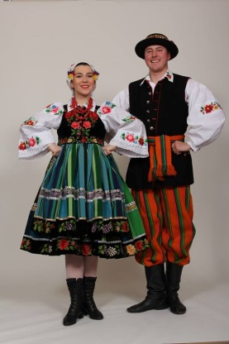
4-Which one is the Hungarian dish?
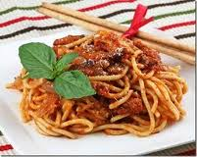
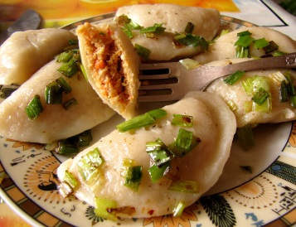
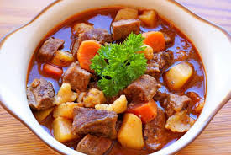
Goula

- b) c)
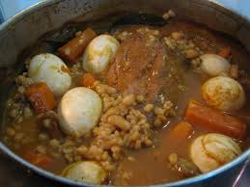
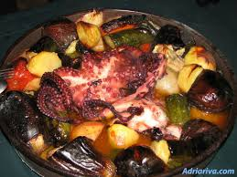
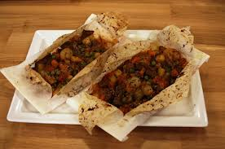

d) e) f)
5-Please write 3 popular places you remember in Hungary.

6-In which city are you doing this Comenius Project in Hungary?

7-What is Szolnok famous for?

8-Which one is the name of the Hungarian school?
a) Kodály Zoltán Általános Iskola
b) Széchenyi István Gimnázium
c) Kassai Úti Magyar-Angol Két Tanítási Nyelvű Általános Iskola
d) Varga Katalin Gimnázium

9-What does the Hungarian word ’’Jó reggelt’’mean?
a)good morning c)goodbye e) see you
b)good afternoon d)thank you

10-Match the numbers with their meanings.
- 1 1) négy
- 2 2) három
- 3 3) egy
- 4 4) öt
- 5 5) kettő

GOOD LUCK!
Valéria Somogyiné Mokrai
English Teacher/ Coordinator

.

