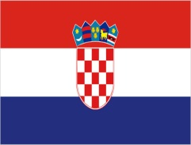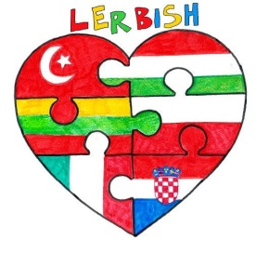

QUESTIONNAIRE ABOUT CROATİA

1.What is the capital city of Croatia?____________________________

2. Circle the Croatian flag
a) 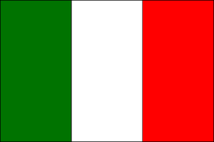 b) c) 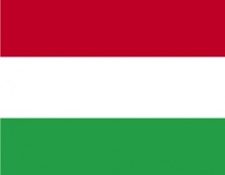

d) 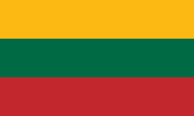 e) f) 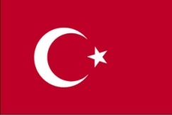

3. What is Croatia famous for?
_______________________________________

4. Circle the traditional costume of Croatia
- 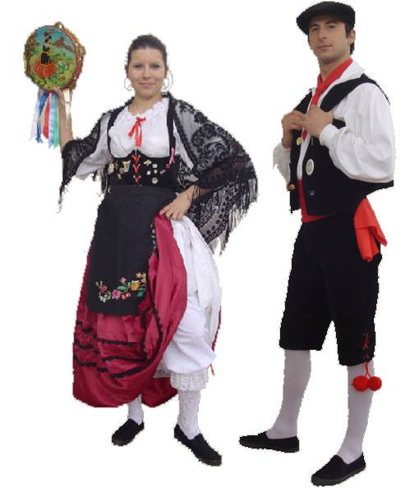 b) 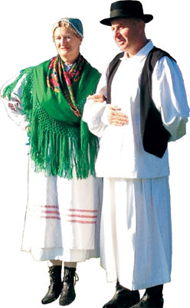 c ) 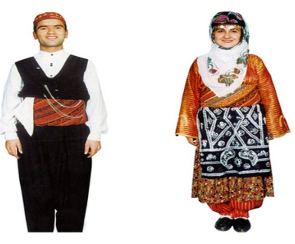
d) 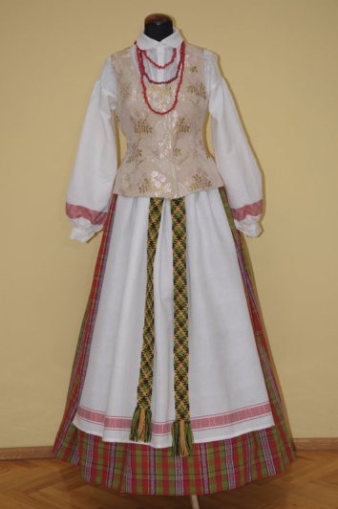 e) 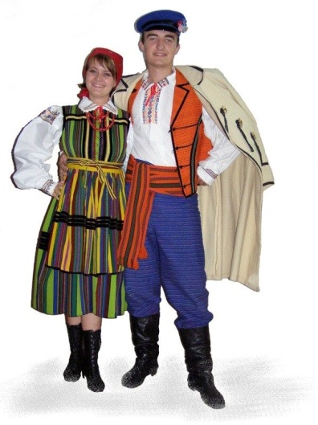 f) 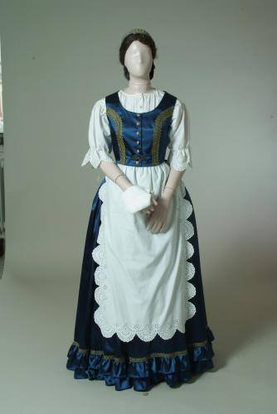

5. Circle! Which one is the Croatian dish?
a) 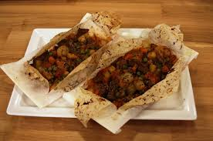 KAĞIT KEBAB d) 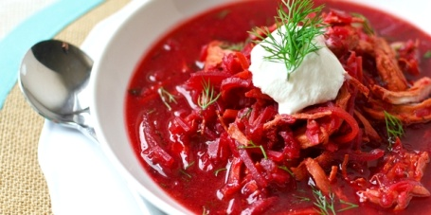
b) 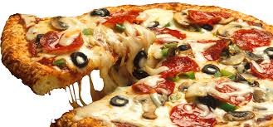 PIZZA e) 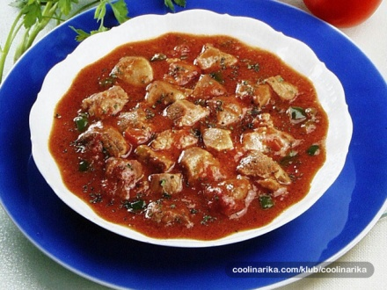
c) 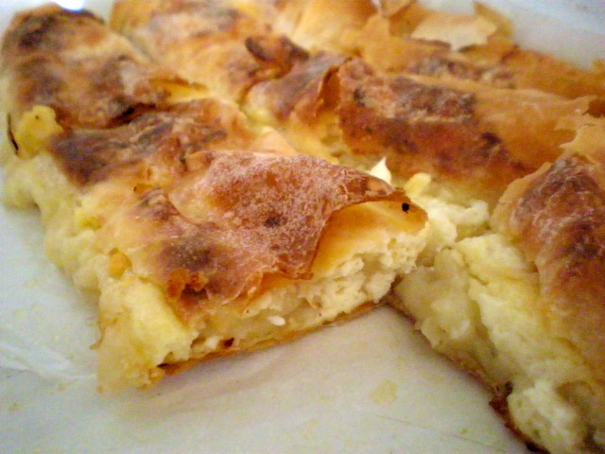 ŠTRUKLI f) 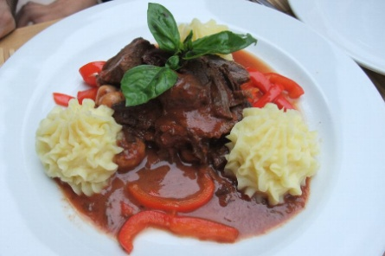

6.Please write 3 popular places in Croatia.
_______________________________________________________
_______________________________________________________
_______________________________________________________

7. In which village are you doing the Comenius project with in Croatia?
_____________________________________________________
8. Which one is the name of the school from Croatia?
a) Gymnasium John Kranjcar Đurđevac
b) Elementary school prof.Franje Viktor Signjar
c) Primary school Molve

9. What does ‘’ Dobar dan’’ mean in Croatia?
a)good morning c)goodbye e) see you
b)hello d)thank you

10. Match the numbers with their meanings.
- 1 1)dva
- 2 2)tri
- 3 3)četiri
- 4 4) pet
- 5 5) jedan

GOOD LUCK!

English Tecaher Mirjana Kelemin

