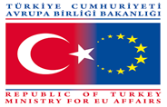
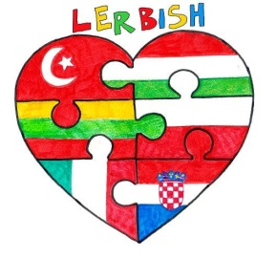

WORDSEARCH
Hi dear students! We want you to find the capitals and cities of the Comenius Partner Countries and also some words you have learnt so far related to partners

T | A | R | A | N | T | E | L | L | A | M | S | B | W | M
V | F | A | N | E | W | R | O | Z | E | N | E | U | J | O
A | C | Q | K | G | R | A | B | I | A | V | D | D | S | L
R | E | W | A | X | R | O | M | E | S | Z | W | A | Z | V
E | D | Z | R | L | C | A | R | A | T | M | A | P | O | E
N | E | W | A | R | O | R | B | T | E | H | R | E | L | U
A | Z | D | F | G | U | Y | O | I | R | G | S | S | N | K
W | A | R | S | E | R | X | U | S | C | B | A | T | O | F
F | G | O | U | Y | L | E | T | V | S | A | W | U | K | J
G | O | U | L | A | S | H | B | E | B | H | T | I | P | O
A | C | R | T | M | A | R | I | N | E | O | I | Z | G | I
C | H | I | L | D | R | E | N | S | D | A | Y | L | U | L
M | A | L | A | T | Y | A | X | S | R | Y | C | F | L | J
M | A | R | Z | I | P | A | N | S | H | E | E | P | T | O
T | A | L | A | M | V | I | L | N | I | U | S | H | E | F

HERE ARE THE WORDS YOU HAVE TO FIND;

1-ANKARA 7-MALATYA 13-TARANTELLA
2-BUDAPEST 8-GRABICA 14-GOULASH
3-ROME 9-MOLVE 15-CHILDREN’S DAY
4-WARSAW 10-SZOLNOK 16-EASTER
5-VILNIUS 11-MARINEO 17-NEWROZ
6-ZAGREB 12-VARENA 18-MARZIPAN SHEEP
19-CROSS HILL

GOOD LUCK!

Seher Türkhan Eren
English Teacher/Coordinator

